Electrical and Computer Engineering Capstone Project Proposal

Version 2.0

2/27/2015

**Erebus Labs**

**Open Sensor Platform**

Submitted By:

**Colten Nye**

**Steve Peirce**

**Golriz Sedaghat**

Supervisor:

**Dr. Lisa Zurk**

Sponsors:

**Dr. Mike Borowczak**

**Dr. Andrea Burrows**

Contents

Abstract 3

Introduction 3

Sponsor 3

Problem Description 3

Previous Attempts 4

Existing Products 4

e-Health Shield 4

NODE 4

ArduIMU 5

Project Statement 5

Methodology 6

Hardware 7

Main board 7

Sensor Boards 8

Firmware 10

Software 10

Configuration 10

Programming 10

Support 10

Schedule 10

Budget 10

Revision History 10

# Abstract

-needs filled out-

# Introduction

An understanding of science and technology is necessary for anyone who wishes to make informed choices about issues in todays’ society. Recently there has been a significant focus on beginning technical education in Science, Technology, Engineering and Mathematics (STEM) at an earlier age. Efforts have been made to promote interests in STEM related fields among the students and encourage them in considering an STEM career in the future as well as providing the necessary background skills.

This document proposes the design and implementation of an open-source sensor platform; allowing a target audience of K-12 students and their teachers to collect and analyze data. This is accomplished by either employing the supported sensors associated with the platform or connecting their own sensor modules via an open-sourced interface specification should the desired sensors not yet be supported. Once collected, students are able to process and analyze the data using their preferred methods.

## Sponsor

The focus of our sponsor, *Erebus Labs & Consulting LLC*, is on the development of Secure Hardware/Software solutions with a focus on Educational Outreach and STEM integration in K20 classrooms. In this respect, one of the concerns has been regarding K-12 students using sensor platforms which often require programming/electronics experience which is an impediment to the use of such devices. Beyond of which there are virtually no affordable approaches to the sensor designs available for K12 students and their respective classroom budgets.

## Problem Description

Current sensor platforms are either completed, closed source, and expensive, or partially open, non-customizable, and trivial. The goal is to build an open source, fully contained sensor platform / collection system for $25-$50 USD for at-volume runs. The platform must support the ability to add modular physical sensors.

## Previous Attempts

There has been previous related work done in the field by a Portland State University capstone team last year, 2013-14, which would be considered as a first revision proof of concept for this design. However, the implementation was highly complex and required experience in not only circuit and software design, but also the Linux operating system. Many students and teachers alike lack these prerequisite skills, therefore defeating the very purpose of the project in a usability sense.

## Existing Products

We explored existing products that may solve the problem. The common issue with the devices we found is that they are prohibitively expensive.

### e-Health Shield

The e-Health Sensor Shield allows Arduino and Raspberry Pi users to perform biometric and medical applications by using 10 different sensors. Biometric information gathered can be wirelessly sent using Wi-Fi, 3G, GPRS, Bluetooth, 802.15.4 and ZigBee depending on the application. The complete kit is available for € 450 ($512 approximately).

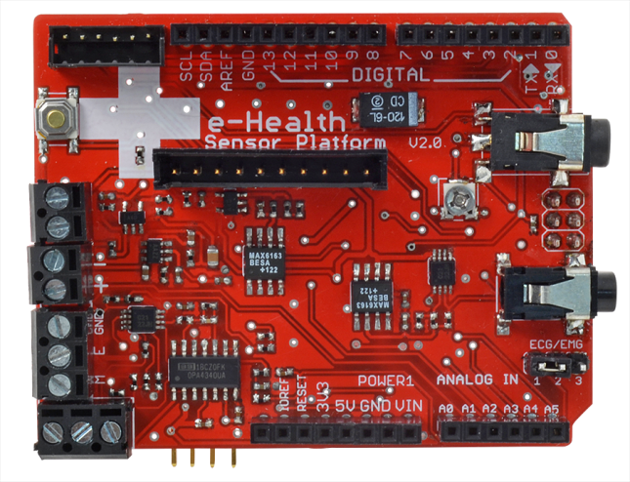

### NODE

The NODE Sensor Platform allows students to explore concepts in science. Data can be collected using Vernier’s Graphical Analysis on iOS or Android devices. The NODE Sensor Platform includes accelerometer, gyroscope, and magnetometer. Two expansion ports allow students to connect additional sensor modules. The platform is available for $149. Not only is this product outside of the target price range, it is not open-source, as is required by the sponsor.

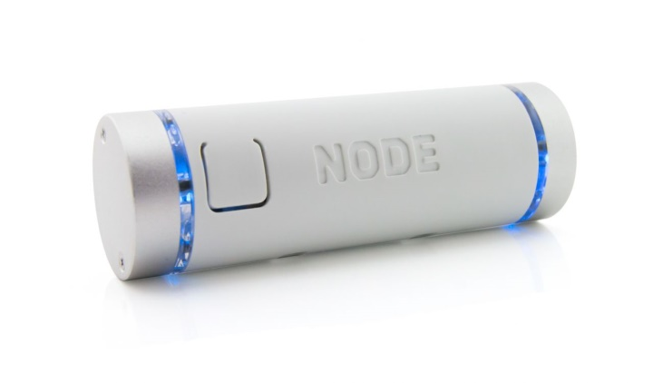

### ArduIMU

ArduIMU V4, An Arduino Based Integrated Measurement Unit, is a fully open source complete wireless sensor module. That gives access to SPI, I2C, UART, analog input and PWM output, which would allow developers to design and develop their custom shields. ArduIMU V4 is available for $129.95, which is again outside the target price range.

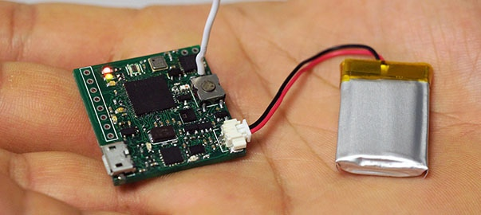

# Project Statement

Our goal is to design and prototype an open-source hardware/software solution for collecting data from sensors that is both inexpensive and accessible to non-technical users. This solution will consist of the main device, a web application for programming the device, and a number of peripheral sensors. We will consider the project a success if we can procure the programming application, at least 2 working main boards, 4 working sensor boards (2 of each connection type, as described below), and demonstrate successful system integration by May 6, 2015.

# Methodology

-continue revising from here-

|  |  |  |
| --- | --- | --- |
| Processor | STM32F205X  Microcontroller | Microcontroller communicates with the sensor boards, reading the collected data from the sensors on a predetermined interval, via the browser configuration tool. |
| Sensor and main board interface | ADC, I2C | The system should be able to identify and support different types of communication via I2C or analog input via ADC. |
| I2C Type Sensor board | Accelerometer | Sensor boards are designed to be “stackable” for I2C devices as they are uniquely addressable as per I2C specification. |
| ADC Type Sensor board | Volatile Organic Compound (VOC) | The ADC channels have a predetermined “snap-in” connector type thereby limiting the possibility of damage due to incorrect installation. |
| Storage | SD Card | Sampled data is logged to an SD Card for safe storage after power-loss or in case of a physically damaging event. |
| Main board programming | JTAG ICP interface through development environment | This programming must be done at least once prior to shipment, and is referred to as “In Circuit Programming”. |
| Development Board | Keil ULINK Pro | This bootloader firmware allows the HID (Human Interface Device) connection over USB to support the browser-based editing. |
| User interface design | Chrome based web browser application | User is able to connect to the system via USB, and program the sensor values through a Chrome based web browser application, via STM’s supported “In Application Programming”, referred to as IAP. |
| Data collection | Flash memory | User is able to save the collected data on a flash memory to prevent data loss, as well as extract the collected data for further analysis. |
| Open Source Design |  | A more advanced user is able to customize the bootloader using a JTAG unit, but there is no need for the user to modify the bootloader while using the platform. |

## Hardware

### Main board

|  |  |
| --- | --- |
| Microcontroller | STM32F205X (STMicroelectronics) |
| Communication Interfaces | Up to 3 I2C (Inter-Integrated Circuit)  Up to 3 SPI (Serial Peripheral Interface)  On-board SDIO (Secure Digital Input Output) Interface |
| Advanced Connectivity | USB 2.0 full-speed/high-speed device/host/On-The-Go controller with dedicated DMA (Direct Memory Access)  Ethernet |
| Memory Type | Up to 1MByte Flash Memory |
| Clock Source  Characteristics | 4 – 26 MHz crystal oscillator  32kHz oscillator for RTC (Real Time Clock) with calibration |
| Low Power | 1.8 to 3.6V operating supply voltage  Sleep, Stop and Standby modes  VBAT supply for RTC (Real Time Clock)  Power-ON Reset Circuitry  Power-Down Reset Circuitry  Brown-out Reset Circuitry |
| Other peripherals | Up to 17 Timers  Three 12-bit Analog to Digital Convertors /Two 12-bit Digital to Analog Convertors  Camera interface  Random number generator |
| Debug and programming mode | SWD (Serial Wire Debug)  JTAG (Joint Test Action Group) In Circuit Programming |
| Software Platform | STM32Cube initialization code generator  Cortex Microcontroller Software Interface Standard (CMSIS) |
| Development environment | CooCox CoIDE  OpenOCD  Keil uVision |

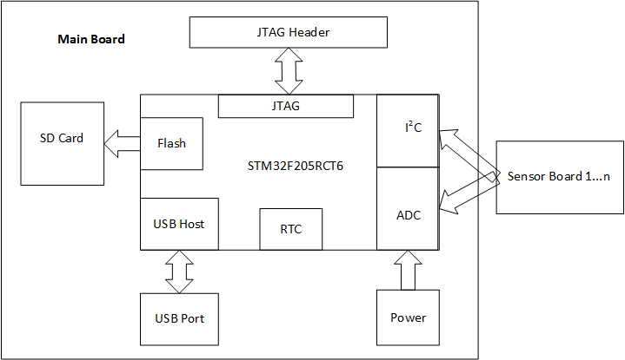

Figure 1.1 – High Level System Design

### Sensor Boards

|  |  |
| --- | --- |
| Accelerometer | SparkFun Triple Axis Accelerometer Breakout - MMA8452Q |
| Communication Interface | I2C digital output interface (operates to 2.25 MHz with 4.7 kΩ pull-up) |
| Operating Voltage range | 1.95 V to 3.6 V supply voltage  1.6 V to 3.6 V interface voltage |
| Output characteristics | Output Data Rates (ODR) from 1.56 Hz to 800 Hz  12-bit and 8-bit digital output |
| Other characteristics | Low power consumption  Two interrupt pins, which allows power savings by relieving the host processor from continuously polling data  Current Consumption: 6 μA – 165 μA |

|  |  |
| --- | --- |
| Volatile Organic Compound (VOC) Sensor | Carbon monoxide gas sensor detection alarm MQ-7 |
| Communication Interface | ADC interface |
| Output characteristic | Analog output |

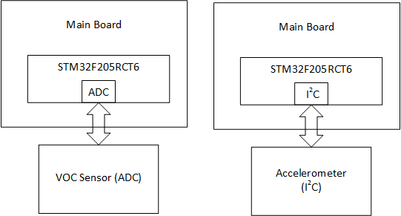

Figure 1.2 - Sensor Connections

## Firmware

## Software

### Configuration

#### System Configuration

#### Sensors Configuration

### Programming

## Support

# Schedule

# Budget

# Revision History

|  |  |  |  |
| --- | --- | --- | --- |
| **Version #** | **Revision Date** | **Author** | **Comments** |
| 1.1 | 1/14/2015 | Golriz Sedaghat | Changes were made in Detailed Problem Description and Methodology, also figure 1 has been modified and figures 2 and 3 has been added |
| 2.0 | 2/27 | Colten Nye | Restructured and updated entire document |
|  |  |  |  |
|  |  |  |  |
|  |  |  |  |